SF.SmokeTest_Manager_TC_SF_ManagerLogin_Instance1_12-Apr-2017_10-44-11_AM_Invoke_Application.png



SF.SmokeTest_Manager_TC_SF_ManagerLogin_Instance1_12-Apr-2017_10-44-19_AM_Login.png

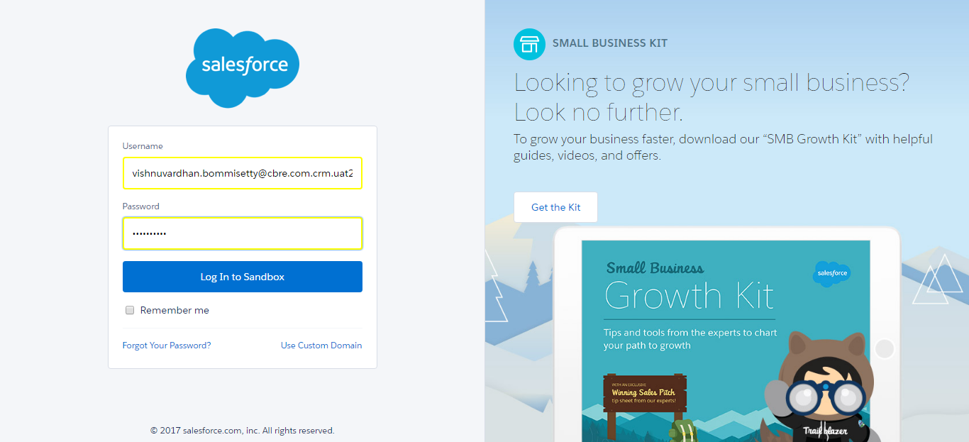

SF.SmokeTest_Manager_TC_SF_ManagerLogin_Instance1_12-Apr-2017_10-44-33_AM_Verify_Logout.png

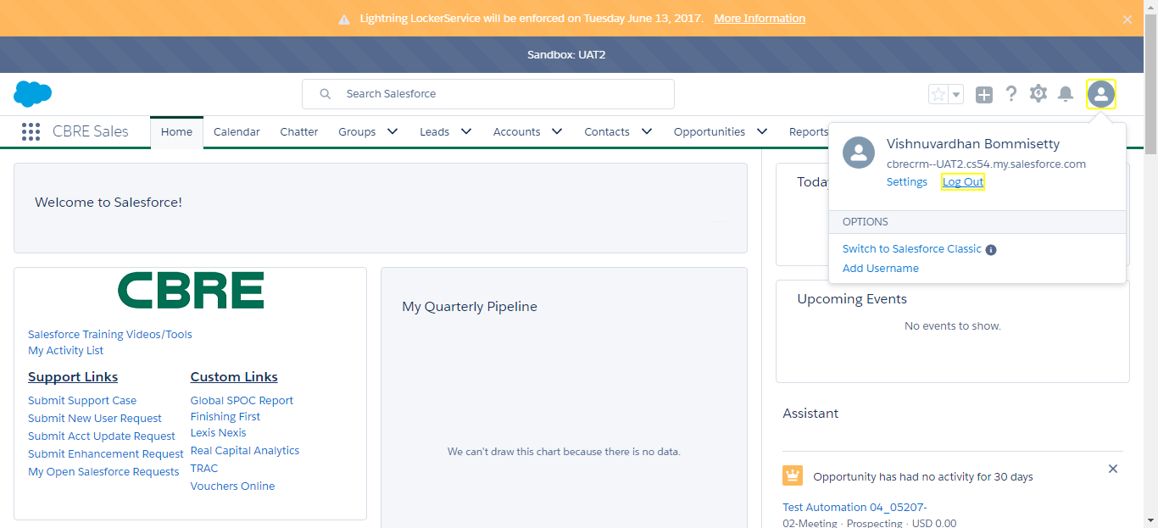

SF.SmokeTest_Manager_TC_SF_ManagerLogin_Instance1_12-Apr-2017_10-44-41_AM_Invoke_Application.png



SF.SmokeTest_Manager_TC_SF_ManagerLogin_Instance1_12-Apr-2017_10-44-49_AM_Login.png

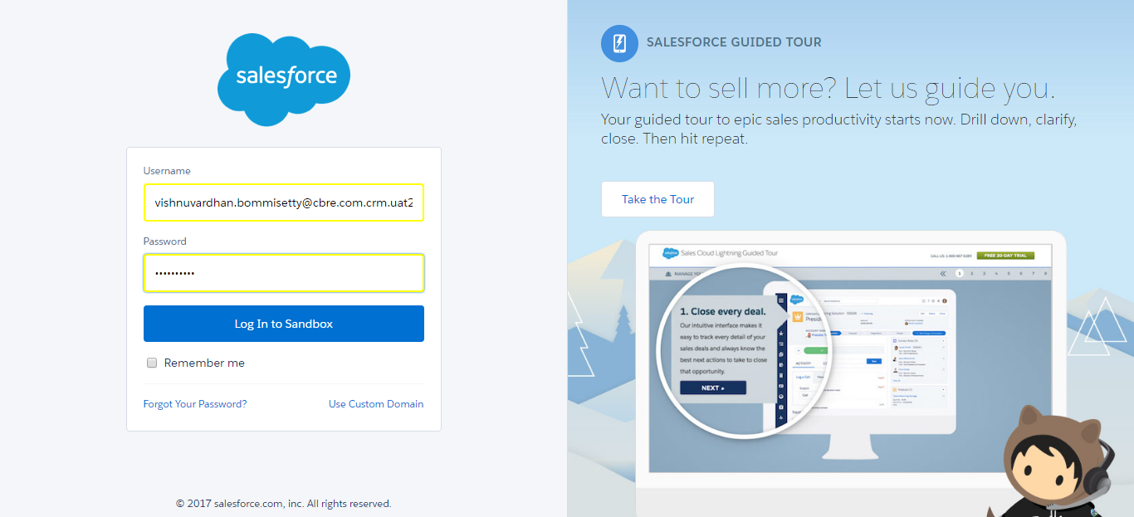

SF.SmokeTest_Manager_TC_SF_ManagerLogin_Instance1_12-Apr-2017_10-45-04_AM_Verify_Logout.png

